Lab Test-2

Subgroup G
G.1 — [S20G1] Sum CSV column ignoring bad rows
Context:
CSV exports in urban public transit (metro/bus) have invalid numerics.

Your Task:
Sum 'value' ints; skip invalid rows.

Data & Edge Cases:
id,value
1,10
2,NA
3,7 -> 17.

AI Assistance Expectation:
Use AI to draft csv.DictReader solution and tests.

Constraints & Notes:
Optionally report skipped count.
Prompt:
csv exports in urban public transit(metro/bus) have invalid numbers, take id and values as input and make sum of int value and skip the invalid rows, the output should print the sum of values
Output:

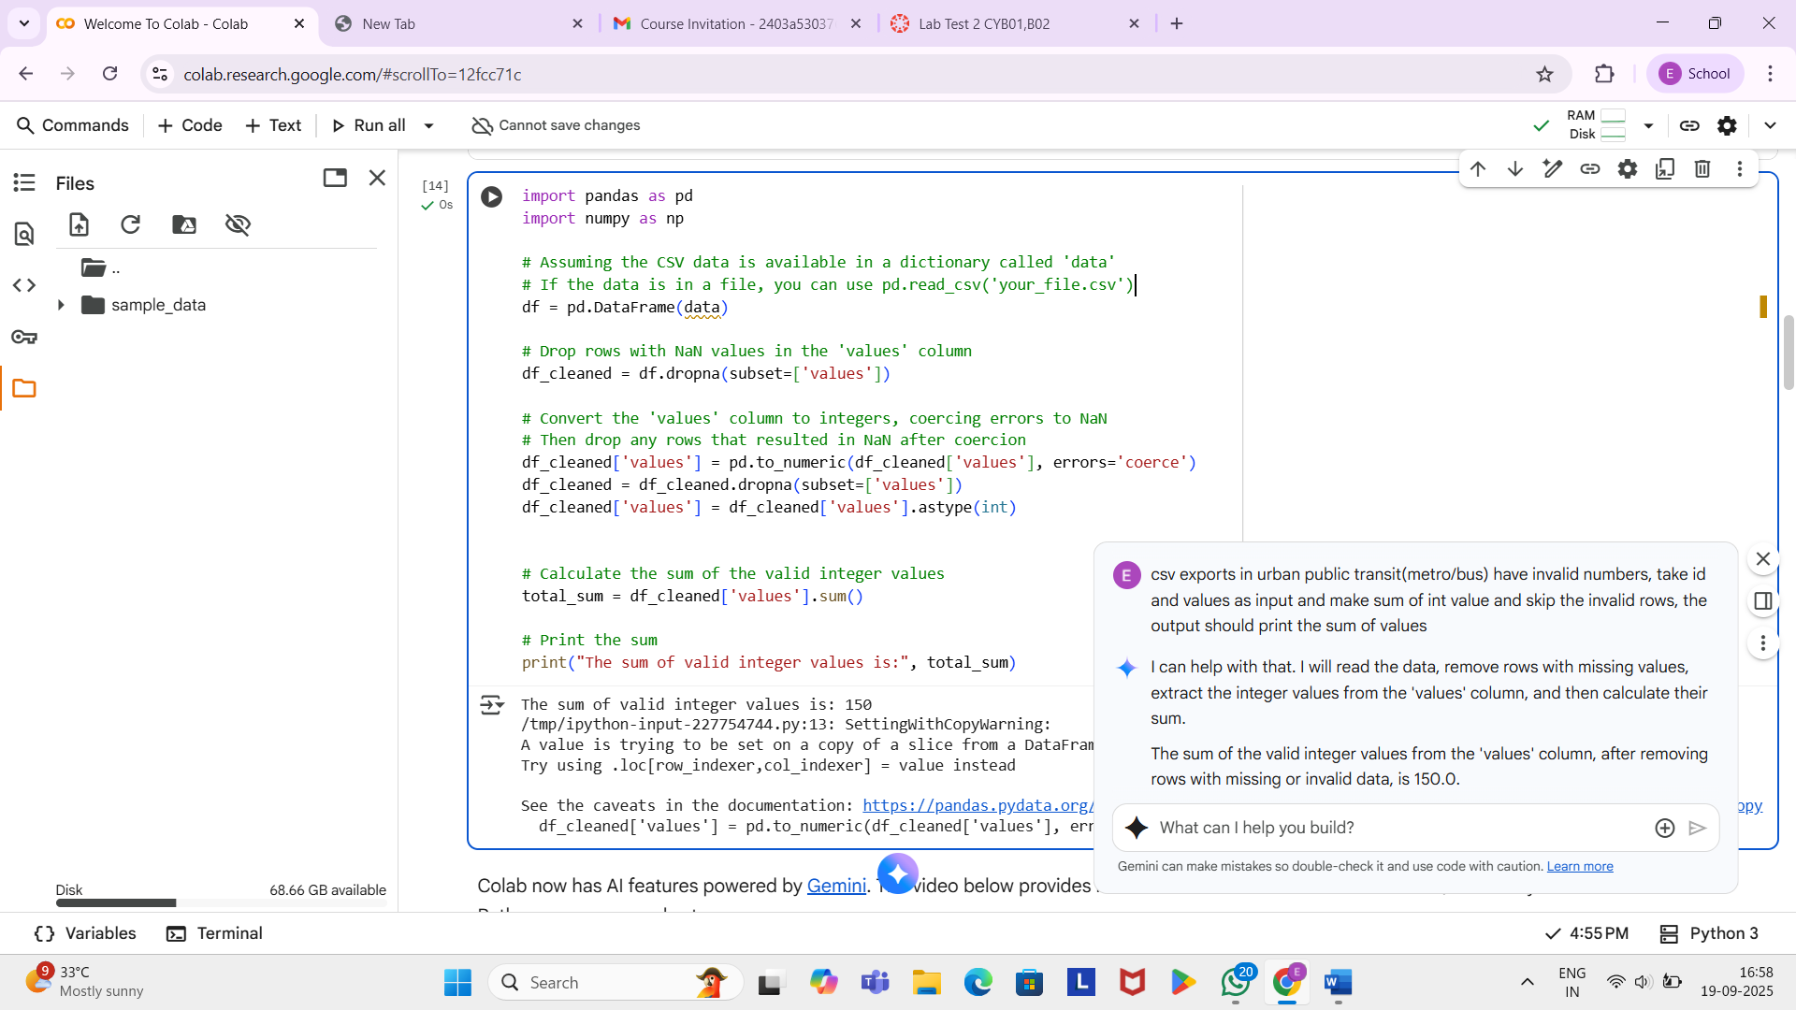

G.2 — [S20G2] Merge two CSVs by id
Context:
Merge two CSVs in urban public transit (metro/bus) by id.

Your Task:
Implement inner & left joins without pandas.

Data & Edge Cases:
A:id,price; B:id,qty.

AI Assistance Expectation:
Dict map + loops; add tests.

Constraints & Notes:
Stable order preferred.

Prompt:
Merge two CSVs in urban public transit (metro/bus) by id. implement inner & left joins without pandas. take input values of 2 tables whose values are A:id,price; B:id,qty. take the id, price, qty as the input the output should be inner joins and left joins with a Stable order preferred.

Output:

